|  |  |  |
| --- | --- | --- |
| https://upload.wikimedia.org/wikipedia/commons/thumb/4/4e/VU_Logo.png/260px-VU_Logo.png | Computer Architecture and Assembly Language Programming (CS401)  Assignment No. 2  (Solution) | Total marks = 20  Deadline Date:  June 3, 2021 |
| Please carefully read the following instructions before attempting assignment.  RULES FOR MARKING  It should be clear that your assignment would not get any credit if:   * The assignment is submitted after the due date. * The submitted assignment does not open or file is corrupt. * Strict action will be taken if the submitted solution is copied from any other student or from the internet.   You should concern the recommended books to clarify your concepts as handouts are not sufficient.  You are supposed to submit your assignment in .doc or docx format.  Any other formats like scan images, PDF, zip, rar, ppt and bmp etc. will not be accepted.  Lectures covered: 7-14  Topics covered: Addition, Loop, Branching and sorting | | |
| NOTE  No assignment will be accepted *after the due date via email in any case* (whether it is the case of load shedding or internet malfunctioning). Hence refrain from uploading your assignment in the last hours of the deadline. It is recommended to upload the solution file at least two days before its closing date.  If you find any mistake or confusion in the assignment (Question statement), please contact your instructor before the deadline. After the deadline, no queries will be entertained in this regard.  For any query, feel free to email at [cs401@vu.edu.pk](mailto:cs401@vu.edu.pk) | | |

**Q. Write an assembly language program to sort all digits of your VUID. For example, if the VUID is** **MC190357324, then you need to sort all the digits except the two alphabets using insertion sort. Also, add all the sorted digits and store the sum in memory.**

**Note: Make it sure to use your own VUID, otherwise zero marks will be awarded.**

**Submission details**

**Following are required in a single MS-Word document:**

* **Assembly language program.**
* **Screenshot of AFD debugger showing the sorted VUID and the sum of its digits in the memory.**

**Solution:**

; sorting a list of VUID numbers using Insertion Sort

[org 0x0100]

jmp start

total: dw 0

data: dw 1,9,0,3,5,7,3,2,4 ;example VUID data list

start: mov cx,2

std1: mov bx, cx

loop1: mov ax, [data+bx]

cmp ax, [data+bx-2]

jge noswap

mov dx, [data+bx-2]

mov [data+bx-2], ax

mov [data+bx], dx

noswap: sub bx, 2

cmp bx, 0

jne loop1

add cx, 2

cmp cx, 20

jne std1

mov bx, data ; point bx to first number

mov cx, 9 ; load count of numbers in cx

mov ax, 0 ; initialize sum to zero

std2: add ax, [bx] ; add number to ax

add bx, 2 ; advance bx to next number

sub cx, 1 ; numbers to be added reduced

jnz std2 ; if numbers remain add next

mov [total], ax ; write back sum in memory

mov ax, 0x4c00 ;terminate program

int 0x21

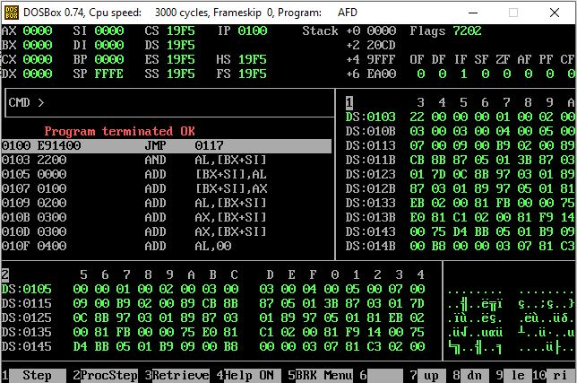

**“The End”**